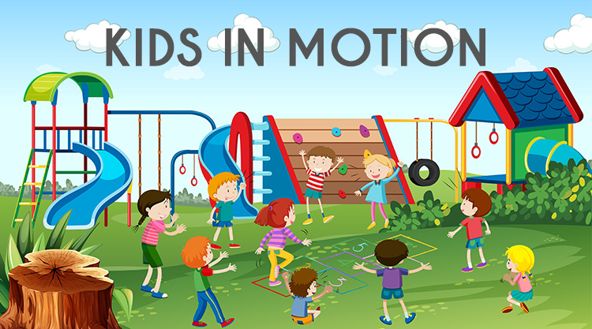
An after school games group with a focus on motor planning, strength, coordination, sequencing, body awareness around peers, executive functioning skills, and expansion of leisure skills. Kids in Motion will involve participation in common group games with a motor emphasis. The club provides Cooke students a special opportunity to participate in social experiences that can translate into functional fun at birthday parties, the playground, and with friends and family. Kids in Motion is planned and led by CGS Occupational Therapists to assist with functional engagement for all students!

Kids in Motion Members: This club is designed for children in 2nd grade and up, that would benefit from facilitated games to help participate in common games and activities.
Topics and Skills Addressed
- Participation in commonly played schoolyard, playground, birthday party, and childhood games
- Develops underlying sensory and motor skills, including strengthening, coordination, body awareness, and motor planning
- Builds leisure skills and preferred activities
- Supports executive functioning and social skills
Fall Session Dates
Thursdays 3:30pm-5:00pm October 3rd, 10th, 17th, 24th, 31st & November 14th and 21st
(Note: NO Session November 7th due to Parent Teacher Conferences)
Parents are responsible for picking up their child promptly between 4:50-5:00pm.
Kids in Motion is free of charge. Space is limited. Sign up is first come first serve. We will follow up to confirm your child’s space in the program.
Please cut off and send permission slip below by Friday, September 27th

Please reserve a space for my child____________________________________.
I am aware that the program runs from 3:30-5pm for 7 weeks, on Thursdays after-school. I will make arrangements to pick my child up at 5pm. Dates are as follows: 10/3, 10/10, 10/17, 10/24, 10/31, 11/14, 11/21 (Note: NO session 11/7 due to Parent Teacher Conferences)

Parent Signature_____________________________________________
For Additional Information Contact:
Megan Mdygon@cookeschool.org, Lower School Occupational Therapist
Erika Euzzolino@cookeschool.org, Lower School Occupational Therapist
Briana Btoegemann@cookeschool.org, Lower and Middle School Occupational Therapist

